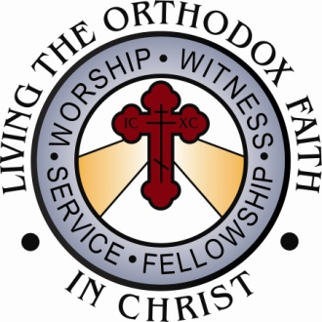
Department of Youth Ministry
Antiochian Orthodox Christian Archdiocese of North America
PO Box 389 • Westwood, MA 02090-0389

September 2009

Time Sensitive Information

Re: Special Olympics Awareness Day (October 18th)
Dear Brother in Christ:
Christ is in our midst!
The third Sunday of October, October 18, 2009 is Special Olympics Awareness Day (SOAD) across our Archdiocese. On Sunday, October 18th, your teen group, or if you have none, your designated representatives, are asked to seek the financial help of your parishioners in funding the 2010 Special Olympics Sports Camp to be held at the Antiochian Village August 13-22, 2010. Next summer we will be celebrating our 30th Annual Special Olympics Sports Camp. This ministry is sponsored by the North American Council of Teen SOYO. Our teens work very hard for this ministry and rely on the generosity and support of the faithful of our Archdiocese and the Order of St. Ignatius.
We Need YOUR HELP!
- Please publicize this day. We have enclosed two bulletin inserts, one for October 11th and the other for October 18th. Please include these inserts in your bulletin and share this cause from the pulpit. Your enthusiastic promotion of such a worthwhile ministry will go a long way in producing fruitful results from our faithful.
- We have found it to be beneficial to have two teens stand next to each breadbasket at the end of Liturgy, one holding a basket for contributions and the other handing out the enclosed Icon bookmarks, which are given as an expression of gratitude for the donor’s financial contribution. We have found this approach to be more effective than having teens stand at the back of the Church, or approach people during coffee hour.
- A couple of years ago we sent each parish a promotional video regarding this important ministry. If possible, perhaps you can show one of the videos to create awareness about the Special Olympics Camp. In the event you need another copy of the DVD, please contact me at fryazge@antiochian.org or 724-238-9565.
- Immediately following Special Olympics Awareness Day, your teens should send their check for the full amount collected in the enclosed envelope to:
Special Olympics Awareness Day
Department of Youth Ministry
PO Box 389
Westwood MA 02090-0389

I appreciate your help in seeing that all the funds are sent to the Department of Youth Ministry by the end of October.

Please make the check payable to NAC Teen SOYO and write in the memo, SOAD.
Please keep us all in your prayers, as we do you. Thank you for your support and help with this ministry.
Your brother in Christ,
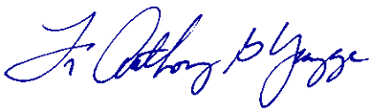
V. Rev. Anthony G. Yazge,
NAC Teen SOYO
Spiritual Advisor & Special Olympics Coordinator

